4. Calculate Interest

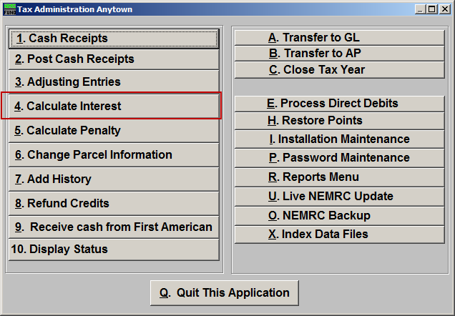
Click on “4. Calculate Interest” from the Main Menu and the following window will appear:

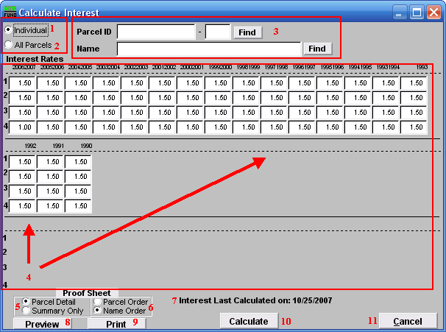
- Individual: Click to choose this option if you want to calculate interest for an individual Parcel.

- All Parcels: Click to choose this option if you want to calculate interest for All Parcels.

- This option is only available if you chose “Individual.” Select the Parcel you are seeking. For additional information on finding Parcels, refer to TA GENERAL PARCEL LOOKUPS.

- Interest Rates: This area displays the interest rates for all Tax Years.

- Parcel Detail OR Summary Only: Include the individual parcel and tax year detail on the proof sheet or report only the totals by Tax Year.

- Parcel Order OR Name Order: If parcel detail is selected above then in which order would you like the information to print out.

- Interest Last Calculated on: xx/xx/xxxx: The system stores the last date interest was calculated.

- Preview: Click this button to preview this report. Refer to GENERAL PREVIEW for more information.

- Print: Click this button to print this report. Refer to GENERAL PRINTING for more information.

- Calculate: It is recommended that you review a proof sheet before clicking to calculate the interest charges.

- Cancel: Click on “Cancel” to return to the Main Menu.

